Answer:

Space and time complexity are considered as major factors for efficiency of an algorithm.

On experimenting breath first search and depth first search for traversing the generated state space tree for a Missionaries and Cannibals game problem, time was calculated for each algorithm, where our time calculation output is shown in the screenshots below:

For BFS:

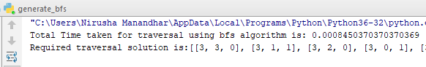

For DFS:

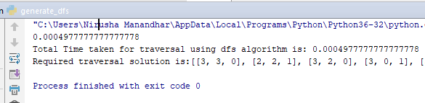

As we can see through above results, in our case, Depth First Search Algorithm is more better in terms of time.